SADA ROTI
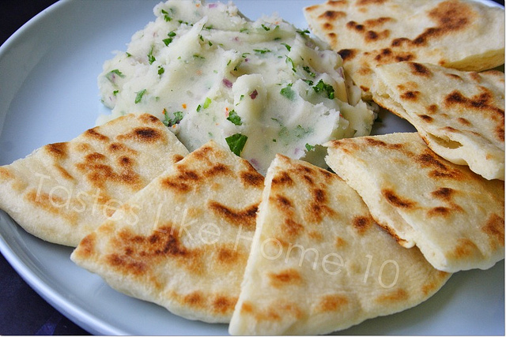

Ingredients
- 4 cups flour, sifted
- 4 tsp. baking powder
- 1 tsp. salt
- 1 ½ cups water or slightly more

Step 1
Combine the flour, baking powder and salt in a medium size bowl. Form a well in the centre andadd all the water, and little more if needed to make soft dough. Knead well and form a large ball .

Step 2
Cover the dough with a damp towel and leave to rest for 1 hour. Divide the dough into four “loyah” (balls) and shape them. Again, allow dough to rest for 1 hour.

Step 3
On a floured board, or clean table top, roll out dough using a bailna (rolling pin) till it is about ½ inch thick and round.
Step 4
Cook on a moderately hot tawah ( griddle) until it rises and turns slightly brown. Turn to the other side and cook.

Step 5
Edges are toasted over the fire to ensure they are cooked. The edges will billow slightly. Place on a clean cloth and cover. Serve hot

