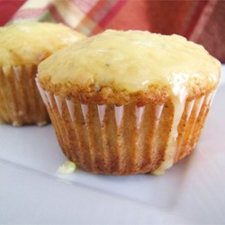
POPPY SEED MUFFINS
Original recipe makes 12 - 18 large muffins
3 eggs
2 1/2 cups white sugar
1 1/8 cups vegetable oil
1 1/2 cups milk
1 1/2 teaspoons salt
1 1/2 teaspoons baking powder
1 1/2 tablespoons poppy seeds
1 1/2 teaspoons vanilla extract
1 1/2 teaspoons almond extract
3 cups all-purpose flour
3/4 cup white sugar
1/4 cup orange juice
1/2 teaspoon vanilla extract
1/2 teaspoon almond extract
2 teaspoons butter, melted

METHOD
25 mins
COOK
20 mins
READY IN
45 mins Directions
Beat together the eggs, 2 1/2 cups white sugar and vegetable oil. Add in milk, salt, baking powder, poppy seeds, vanilla, almond flavoring, and flour. Mix well.
Bake in paper lined muffin cups (filled 3/4 full or 3 small greased loaf pans) at 350 degrees F (175 degrees C) for 15-20 minutes for muffins and 50-60 minutes for loaves. The tops should be browned and a toothpick inserted in the center should come out clean.
Remove muffins as soon as you can while still warm/hot and dunk tops into glaze. Turn right side up and cool on a cookie rack. With loaves just pour the glaze evenly over the three loaves while still in pans. Let cool to a warm temp. and remove from pans. Yes, it is a little messy but it is really good.
To Make Glaze: In a saucepan over low heat, combine 3/4 cup sugar, orange juice, 1/2 teaspoon vanilla, 1/2 teaspoon almond flavoring and 2 teaspoons melted butter. Warm in pan until the sugar is dissolved. Pour over loaf pans or dunk muffin tops into glaze when cooled to room temperature. (Omit the glaze altogether if you don't like the mess.)

