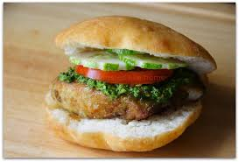

FLOATS
Ingredients
2 cups all-purpose flour
2 1/2 teaspoons baking powder
1/2 teaspoon sugar
1/2 teaspoon salt
2 tablespoons unsalted butter, softened
3/4 cup warm water
Vegetable oil, for frying
Directions
Using a sieve over a large bowl, sift together flour, baking powder, sugar, and salt. Add the butter and, using your fingertips, work it into the flour mixture to form pea-sized pieces. While stirring with a wooden spoon, slowly add water in a stream, until the flour starts to leave the sides of the bowl. When dough is soft, but not sticky, transfer it to a lightly floured work surface.
Knead the dough, divide and roll the dough into small balls the size of golf balls. Cover the dough balls with a damp paper towel, covered by a regular kitchen towel, and let rest for 10 minutes.
Knead the dough balls for a second time until smooth and soft to the touch, and let rest, covered again with the 2 towels, about 10 minutes more.
Using a rolling pin, roll each dough ball into a 4-inch disk
Pour the oil into a wok to a depth of 2 inches. Place the pot over medium heat and heat until a deep-fry thermometer reads 375 degrees F. Working in batches, fry the dough disks, turning once, until golden brown and puffed, about 30 seconds per side. Using a slotted spoon, transfer the bakes to a paper towel-lined plate. Serve with Trinidadian dal, rice, and bhaji,
Read more at: http://www.foodnetwork.com/recipes/fried-bakes-or-floats-recipe.html?oc=linkback

